Displaced Workers Gain New Skills
Illinois Talent Pipeline Grant offers funds for on the job training at CSL Behring.
By Maureen Powell 08 Feb 2018
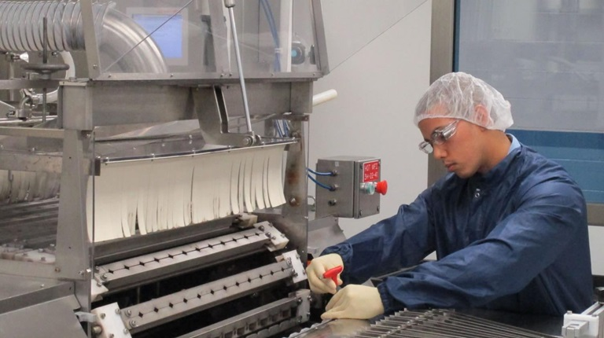
Curtis Cox adjusts a vial washer during his shift in Kankakee. Curtis is one of 36 skilled workers who participated in CSL Behring’s award-winning, on-the-job training program.
Curtis Cox wasn’t waiting his turn. Instead of being scolded for bad manners, he’s being applauded for his foresight. Curtis took action and joined CSL Behring eight months before his former employer, Merisant, closed its doors in December 2016. Merisant, which produced artificial sweeteners, is one of four companies who downsized or ceased operations in the past 24 months in the Kankakee area, impacting more than 300 local workers.
While other companies are making cuts, CSL Behring has increased its workforce in Kankakee by more than 35 percent during the past two years.
To help the company meet this growth, CSL contacted the local Workforce Board to discuss staffing needs and training opportunities. Training funds were secured through the Illinois Talent Pipeline Grant and, in partnership with Kankakee Community College, CSL Behring began retraining workers displaced in the past 24 months.
One such worker was Curtis. His previous experience at the Merisant facility included following Good Manufacturing Practice, standard operating procedures, lean processes, and continuous improvement. This gave him the confidence to apply at CSL Behring. He was impressed with the thorough interview process, which included talking with production supervisors.
“This company is a land of opportunities. I want people to get some inspiration and take advantage, thrive, and flourish here at CSL Behring,” Curtis remarked.
The partnership with the Workforce Board and Kankakee Community College has enabled CSL Behring to train 36 workers under this grant opportunity. The program allows folks to receive the training needed to adapt to a new role, while CSL Behring helps develop a skilled workforce to meet increased demand for its lifesaving medical treatments. As a result of this program, the Kankakee Community College Foundation recently awarded CSL Behring its Partnership Award for its support of student scholarships and the work with the Talent Pipeline Grant.
“Our goal is to collaborate with KCC, supporting displaced workers, to acquire the skills needed to work at our plant,” said Tricia Stewart, Senior Vice President and General Manager at CSL Behring Kankakee. “We are fortunate to be able to hire local people and retrain them with the skills we need.”

